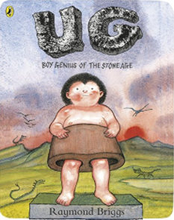
Year 3 Homework.
We have been thinking about how the modern world is different from the Stone Age world Ug lives in.
One of the things we know is different is the amount of technology we have available to us.
To celebrate the amazing world we live in, choose one of the amazing inventors below and spend some time researching them. (You can pick someone that is not on the list if they are interesting to you). While reading about the inventor, try to answer the following questions:
- What did they invent?
- When did they invent it?
- How old were they when they invented it?
- Why was it an important invention? (Do we still remember and talk about this or do we take it for granted?)
- What impact did it have on society? (How did it change the world?)
Make a poster or piece of writing to share your research. Make it look amazing and have lots of fun and interesting facts so we can display them!
Here are some ideas if you need them:
- Thomas Edison Thomas Edison Biography (ducksters.com)
- Marie Curie Biography: Marie Curie for Kids (ducksters.com)
- Louis Braille Facts about Louis Braille for kids (projectbritain.com)
- Stephanie Kwolek TIME for Kids | This is Stephanie: Read the Story of Stephanie Kwolek
- Deepika Kurup Deepika Kurup: Student Scientist – National Geographic Education Blog
- Azza Abdel Hamid Faiad Egyptian Teenager Unveils Plan to Turn Plastic Waste Into $78 Million of Biofuel! (inhabitat.com)
- Steve Jobs Steve Jobs - Kids | Britannica Kids | Homework Help
- Alexander Graham Bell Alexander Graham Bell Facts | Cool Kid Facts

