Roots
Stems
Leaves
Flowers
Broccoli

Carrot
Potatoes Cauliflower
Spinach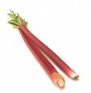 Rhubarb
Lettuce Celery

