Date:

L.O I can use a ruler to measure.
A.
B.
C.
D.
E.
F.
G.
Length =
Length =
Length =
Length =
Length =
Length =
Length =
Now can you put the lines in order shortest to longest?

Shortest
Longest
Date:

L.O I can use a ruler to draw lines o length

Draw the lines to the measurement
2cm =
7cm =
10cm =
5cm =
11cm =

Date:

L.O. I can use meters and centimetres appropriately.

Pur these classroom items in the correct part of the table.
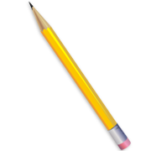
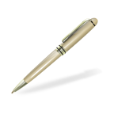

Pencil
Pen


Book
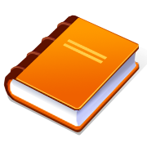

Whiteboard
Laptop

Centimetres | Meters
Now can you find some more objects in the classroom and put them into the table. | Measurements
Date:

L.O. I can use a ruler to solve word & number problems

Use the ruler above to solve these problems

cm
- 4cm + 3cm =

cm
- 5cm + 6cm =

cm
- 9cm + 3cm =

cm
- 7cm – 2cm =

cm
- 12cm – 8cm =

cm
- 10cm – 9cm =
- Zack’s pencil is 4cm long, Amy’s pencil is 5cm longer how long is Amy’s pencil?

cm
- the classroom plant is 6cm tall, during the holiday it grows 4cm how tall is the plant after the holiday?

cm

