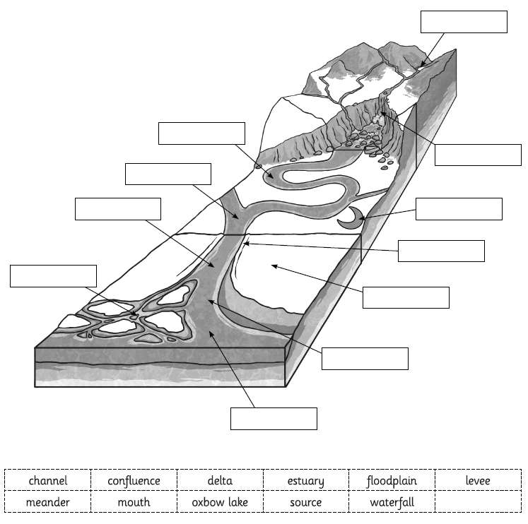
LO: I can identify the different stages along the journey of a river.Hot:
1. Label the diagram using the keywords from the box.
2. Create a glossary explaining the meaning of these words.

LO: I can identify the different stages along the journey of a river.
Hotter:
1. Label the diagram using the keywords from the box.
2. Create a glossary explaining the meaning of these words.

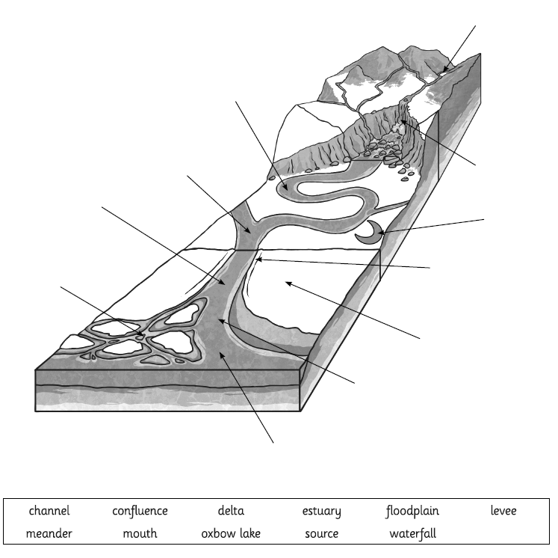
LO: I can identify the different stages along the journey of a river.
Hottest:
1. Label the diagram using the correct keywords.
2. Create a glossary explaining the meaning of these words.
