L.O. : I can read and interpret time-tables. 10/6/2020
Fluency:
1) Use the timetable to answer the questions.
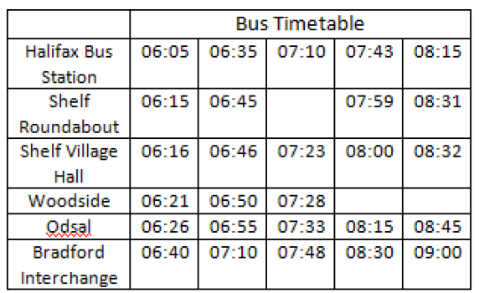

a) On the 06:35 bus, how long does it take to get from Shelf Roundabout to Bradford Interchange?
b) Can you travel to Woodside on the 07:43 bus?
c) Which journey takes the longest time between Shelf Village Hall and Bradford Interchange, the bus that leaves SVH at 06:46 or the bus that leaves SVH at 07:23?
d) If you needed to travel from Halifax Bus Station to Odsal and had to arrive by 08:20, which would be the best bus to catch? Explain your answer.
e) Which journey takes the longest time from Halifax Bus Station to Bradford Interchange?

2) Reasoning
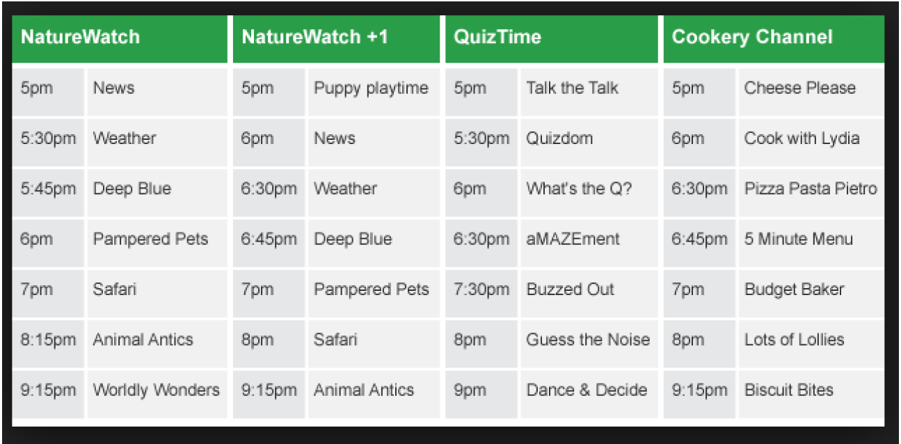

Simon scans the TV guide and plans his viewing for the evening. He chooses this sequence of TV shows: Cheese Please, What’s the Q, aMAZEment, Budget Baker, Safari, Dance & Decide.
- Will Simon be able to watch all the shows he has chosen? Explain.
- It is 18:45. How long is it until “Guess the Noise” is on?

3) Diving Deeper

True or false? - Use the timetable below to answer.
- If Becky was 10 minutes late for her English lesson on Monday there would be 45 mins of the lesson left.
- Becky has 2 hours and 20 minutes of PE in a week.
- Becky has 130 minutes of literacy in a week

