L.O. : I can read and interpret two-way-tables. 9/06/2020
120 people were asked where they went on holiday during the summer months of last year.
In June, 6 people went to France and 18 went to Spain.
In July, 10 people went to France, 19 went to Italy.
In August, 15 people went to Spain.
35 people went to France altogether.
39 people went to Italy altogether.
35 people went away in June.
43 people went on holiday in August.
Fluency:

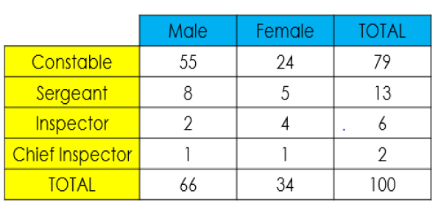
1) Use the table to answer the questions.
a) How many female inspectors work there?
b) How many male sergeants work there?
c) How many constables are there altogether?
d) How many people work at Liverpool police station?
e) How many male inspectors and female constables are there altogether?
f) How many people in total are ranked below inspector?

2) Complete the table and add 5 of your own questions. Then answer them (in your book).
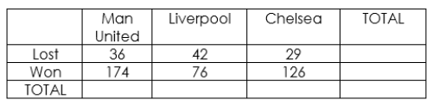

Reasoning Diving Deeper:
3) Fill in the gaps and answer the questions. 4) Create a table for the following information.
Add a title to the table. Remember to give your table a title.
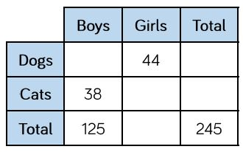
Create & answer 3-5 questions.

a) How many more boys than girls have dogs?
b) How many more girls have cats than dogs?
C) How many more children have dogs
than cats?

