L.O. : I can read tables. 8/06/2020
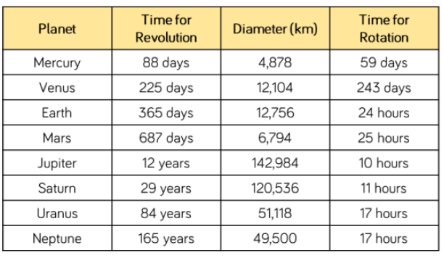
Fluency:1) Use the table to answer the questions.
- How many planets take more than one day to rotate?
- Which planets take more than one year to make one revolution?
- Write the diameter of Jupiter in words.
- What is the difference between the diameter of Mars and Earth?
- What is the difference betwee the time for rotation between Mercury and Venus?
- Create some of your own questions for sombody else to answer.

2) Use the table to answer the questions.
- What is the difference between the highest and lowest population?
- Which two cities have a combined population of 621,000?
- How much larger is the population of Liverpool than Coventry?
- Add your own 2-3 questions.
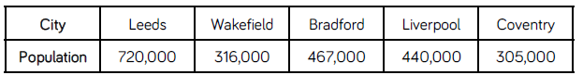

Reasoning
3) Agree or disagree? Explain.
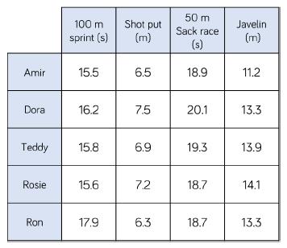

Ron thinks that he won the 100m sprint because he has the biggest number.

Diving Deeper4. True or false? Explain.
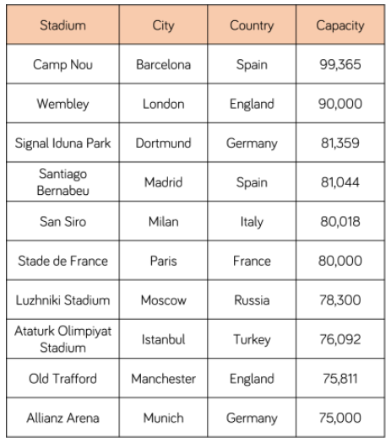
Then 10 largest Football Stadiums in Europe.

