PERSONAL BEST CHALLENGE
Can you beat your scores throughout the week?
Sports Week Activity Tracking sheet
Name: _________________________________
Class: __________________________________
Activity | Monday | Tuesday | Wednesday | Thursday | Friday
1. Around the world.
2. Bean bag throw
3. Star jumps
4. Socks and a box
5. Obstacle course.
Challenge |  |  |  | Dress up as your favourite character when practicing your activities

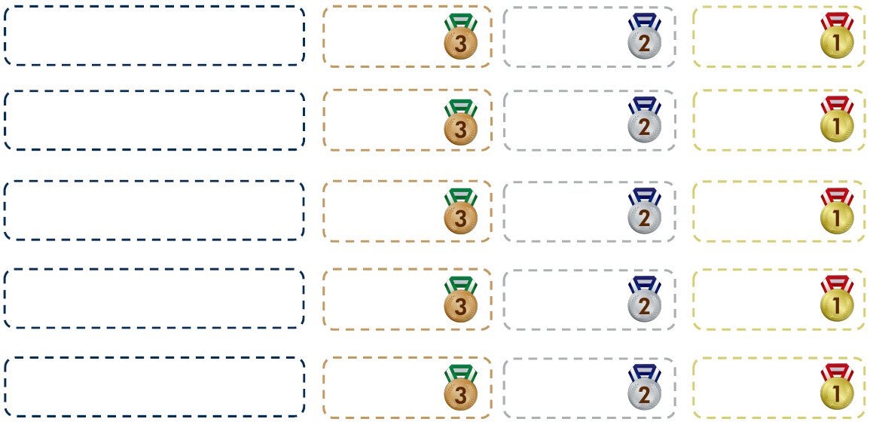
Tick the boxes for your different activities if you achieve bronze, silver and gold!
1.

2.

3.

4.

5.
Challenges (choose one for each day)
- Design your own warm-up
- Make a recipe for an athlete – meal/ smoothie
- Make your own medal to wear on Friday
- Prepare an obstacle course for you and your family to complete
- Make a dance or routine to celebrate sports week
- Create a biography of your favourite athlete.

