Rivers of the UK

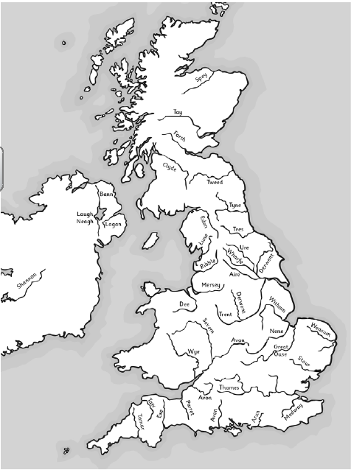  River | Source | Mouth | Key Towns
Spey
Bann
Trent
Mersey
Thames
Severn
Conwy
Tyne
Clyde
Tweed

Clues for source: Southern Uplands (2x), Pennines (3x), Snowdonia, Cambrian Mountains, Cotswold Hill, Sperrin Mountains, Monadhliath Mountains,
Clues for mouth: North Sea (3x), Firth of Clyde, Irish Sea (2x), Bristol Channel, English Channel, Humber Estuary, Atlantic Ocean
Rivers of the World
River | Source (name of country, mountain, ...) | Mouth (name of ocean or sea) | Countries on its course | length
Amazon
Nile
Congo
Ganges
Indus
Loire
Mississippi
Murray
Ob
Yangtze

