Making Muscles
You will need:
elastic bands
strips of thick, strong cardboard
split pin
stapler & scissors
1. Cut two equal lengths of card from thick strong card. | 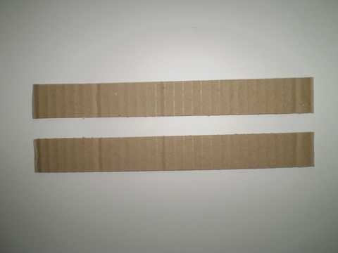
2. Place one strip of card on top of the other.  3. Push a split pin through both pieces of card. This must be no less than 5cm in from the edge. | 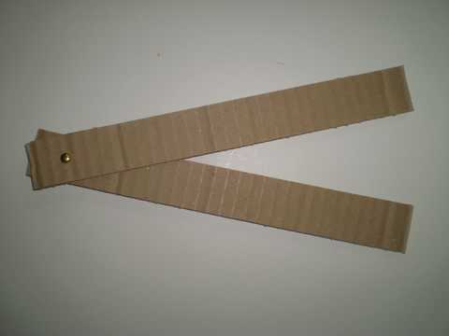
4. Cut 4 elastic bands to length.  Two will be short (red) and two will be need to be longer (green).  5. Staple the elastic bands in place. The two shorter ones will attach on the outside of the arm and the 2 longer bands will attach on the inside of the arm. Attach them all so they are tight but not pulling. | 