Major muscles of the human body

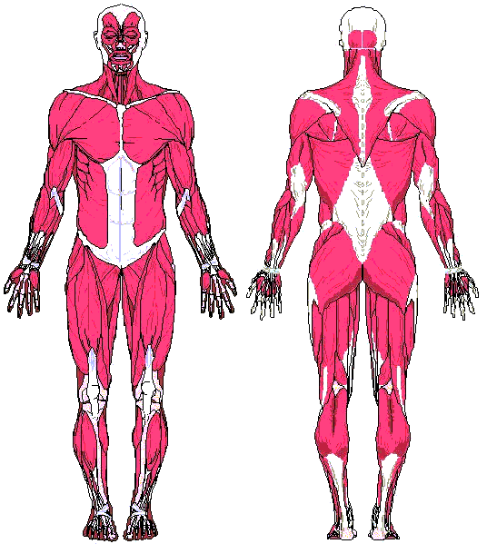
Abdominals Triceps
Biceps Gastrocnemius
Quadriceps Deltoid
Pectoralis major Trapezius
Latissimus Dorsi Hamstrings
Gluteus Maximus Erector Spinae

