Here is a little game for you!
Can you guess what these objects from the past is.
What could it be used for?
What do we use now for the same purpose?
Can you name and draw a picture below?
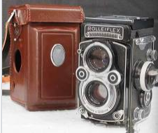 | 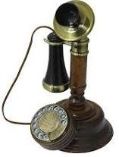 | 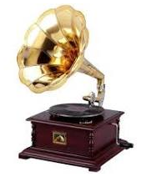
It could be a  camera. It used a film and you need to develop it  It might be used to take black and white photos. | It could be a  phone.  It might be used to make a phone call. | It could be a gramophone and used records.  It might be used  listen to music.
Now we use a digital camera.  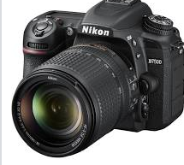  It is made of plastic, glass and metal and takes colour photos, | Now we use a smart phone.  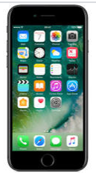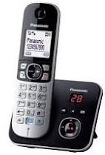  It is made of plastic. | Now we use a CD player and CD’s.  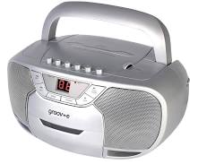  It is made of plastic or metal and used to listen to music.

