Here is a little game for you!
Can you guess what these objects from the past is.
What could it be used for?
What do we use now for the same purpose?
Can you name and draw a picture below?
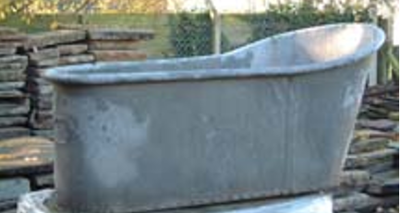 | 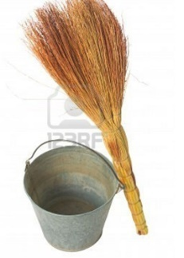 | 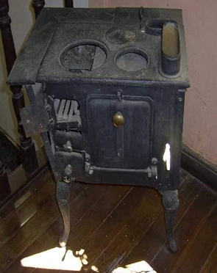
It could be a  metal bath  It might be used to having a bath by filling it with hot water using a kettle. | It could be a  broom and bucket.  It might be used to clean floors | It could be a cooker with coal or wood.  It might be used  cook food.
Now we use a shower or bath.  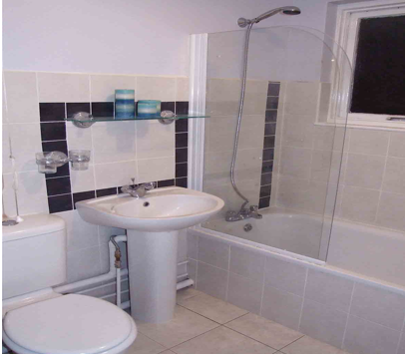  It is made of ceramic or plastic. | Now we use an electric vacuum cleaner.  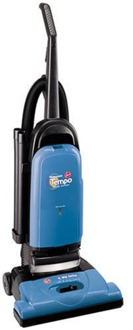  It is made of plastic, metal and rubber | Now we use a electric or gas cooker/ microwave.  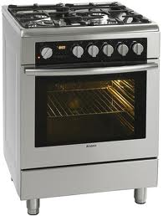  It is made of metal.

