Here is a little game for you!
Can you guess what these objects from the past is.
What could it be used for?
What do we use now for the same purpose?
Can you name and draw a picture below?
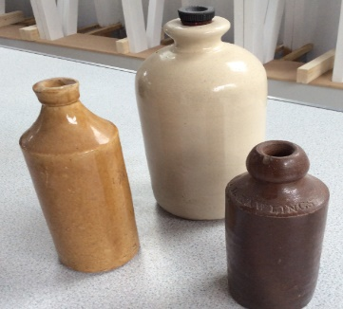 | 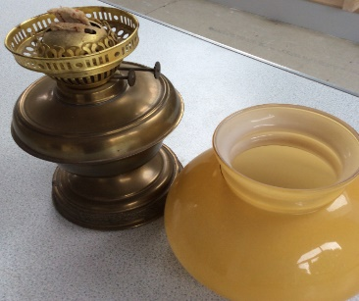 | 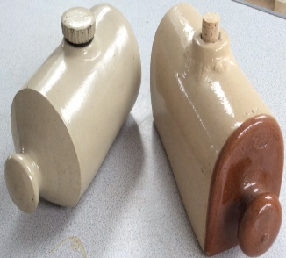
It could be a  It might be used to | It could be an  It might be used to | It could be a  It might be used to
Now we use a  It is made of | Now we use  It is made out of | Now we use a  It is made out of

