Here is a little game for you!
Can you guess what these objects from the past is.
What could it be used for?
What do we use now for the same purpose?
Can you name and draw a picture below?
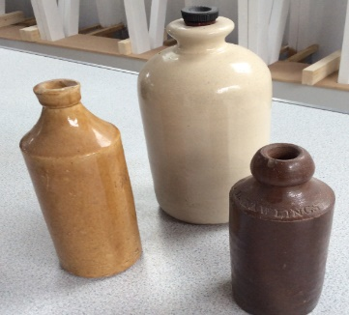 | 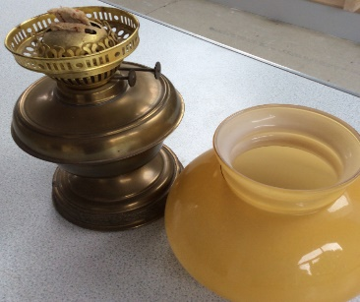 | 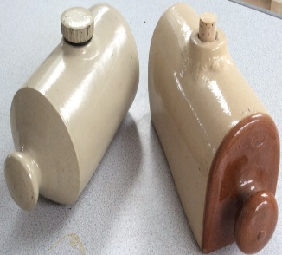
It could be a  Water bottle  It might be used to carry water | It could be an oil lamp.  It might be used to light up the place in the dark. | It could be a hot water bottle.  It might be used to keep warm.
Now we use a water bottle  It is made of plastic.  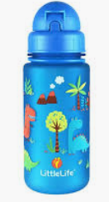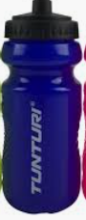 | Now we use an electric bulb.  It is made out of glass and filament.  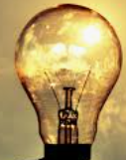 | Now we use a hot water bottle  It is made out of rubber.  