Here is a little game for you!
Can you guess what these objects from the past is.
What could it be used for?
What do we use now for the same purpose?
Can you name and draw a picture below?
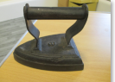 | 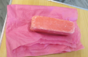  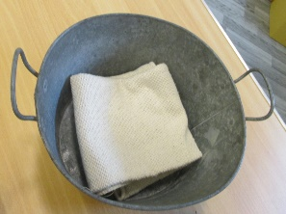 | 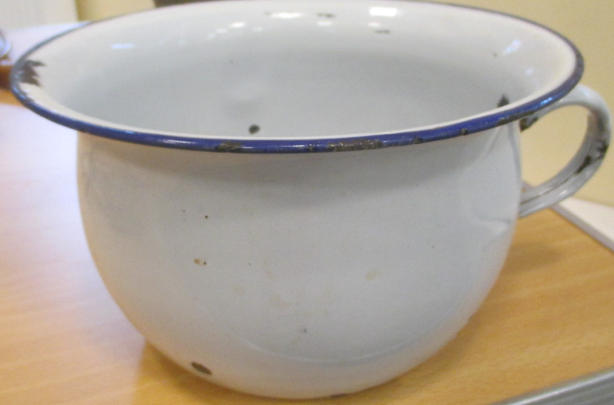
It could be a iron  It might be used to iron clothes. It is made of | It could be a clothes washing bucket and soap  It might be used to wash clothes. | It could be a  chamber pot  It might be used as a toilet.
Now we use an electric iron.  It is made of plastic and metal.  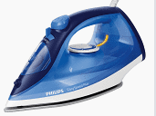 | Now we use a washing machine  It is made out of plastic and metal.  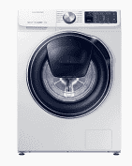 | Now we use a toilet  It is made out of ceramic.  