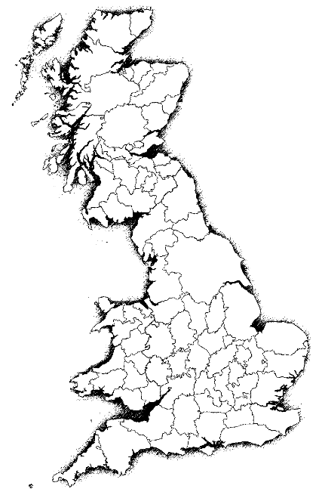
Geography Map Challenge 4

Use an atlas index or internet research to find the features of the British Isles listed below– add to map to show their location

Physical features – Rivers + Seas
- River Severn
- River Tyne
- River Thames
- The North Sea
Physical features - National Parks
- Snowdonia
- Lake District
- Exmoor
- Norfolk Broads
Human Constructs - Cities
- London
- Cardiff
- Edinburgh
- Birmingham
5. Norwich
- Manchester
- Newcastle-upon-Tyne
- Sheffield

