Geography Map Challenge 5

Use the index at the back of the school Atlas to find the places listed below – add the year the city hosted the Olympics to the to map to show their location.
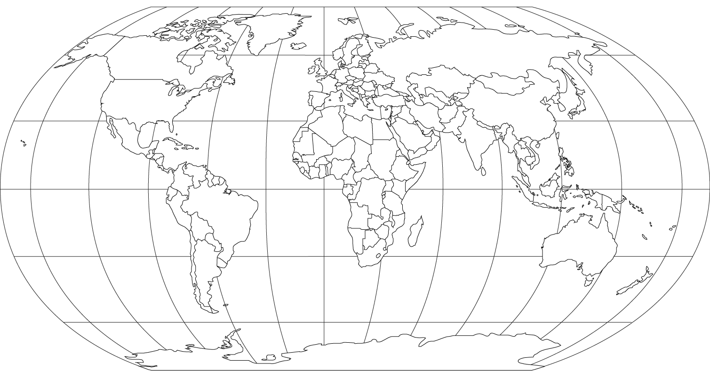

Cities that have hosted the Summer Olympic Games
1896 Athens, Greece
1900 Paris, France
1904 St. Louis, United States
1908 London, England
1912 Stockholm, Sweden
1916 Cancelled (WWI – Berlin had been awarded)
1920 Antwerp, Belgium
1924 Paris, France
1928 Amsterdam, Netherlands
1932 Los Angeles, United States
1936 Berlin, Germany
1940 Cancelled (WWII – Tokyo had been awarded)
1944 Cancelled (WWII – London had been awarded)
1948 London, England
1952 Helsinki, Finland
1956 Melbourne, Australia
1960 Rome, Italy
1964 Tokyo, Japan
1968 Mexico City, Mexico
1972 Munich, West Germany
1976 Montreal, Canada
1980 Moscow, Soviet Union
1984 Los Angeles, United States
1988 Seoul, South Korea
1992 Barcelona, Spain
1996 Atlanta, United States
2000 Sydney, Australia
2004 Athens, Greece
2008 Beijing, China
2012 London, England
2016 Rio de Janeiro, Brazil
2020 Tokyo, Japan

