L.O. I can use the 5 senses to build descriptive vocabulary.

What can you hear?

What can you see?

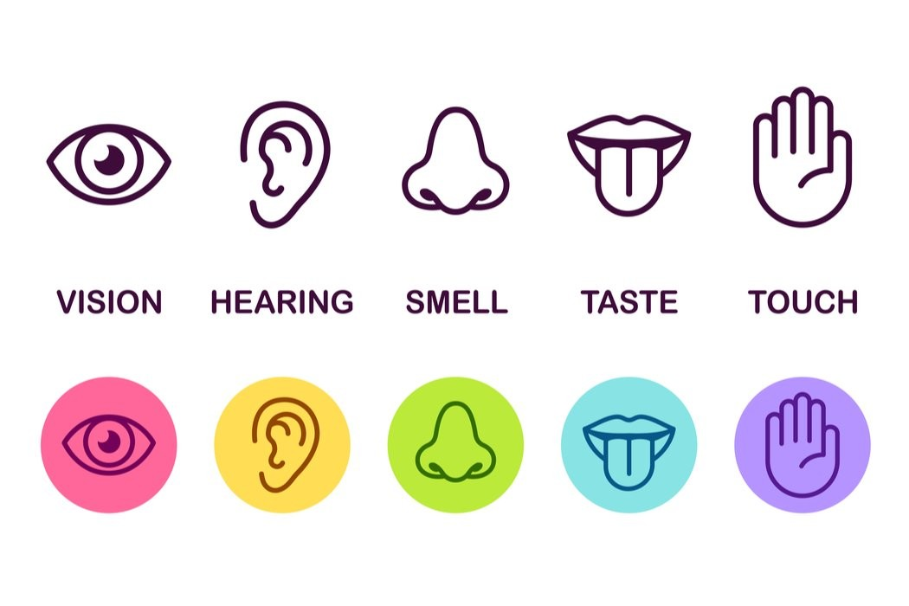

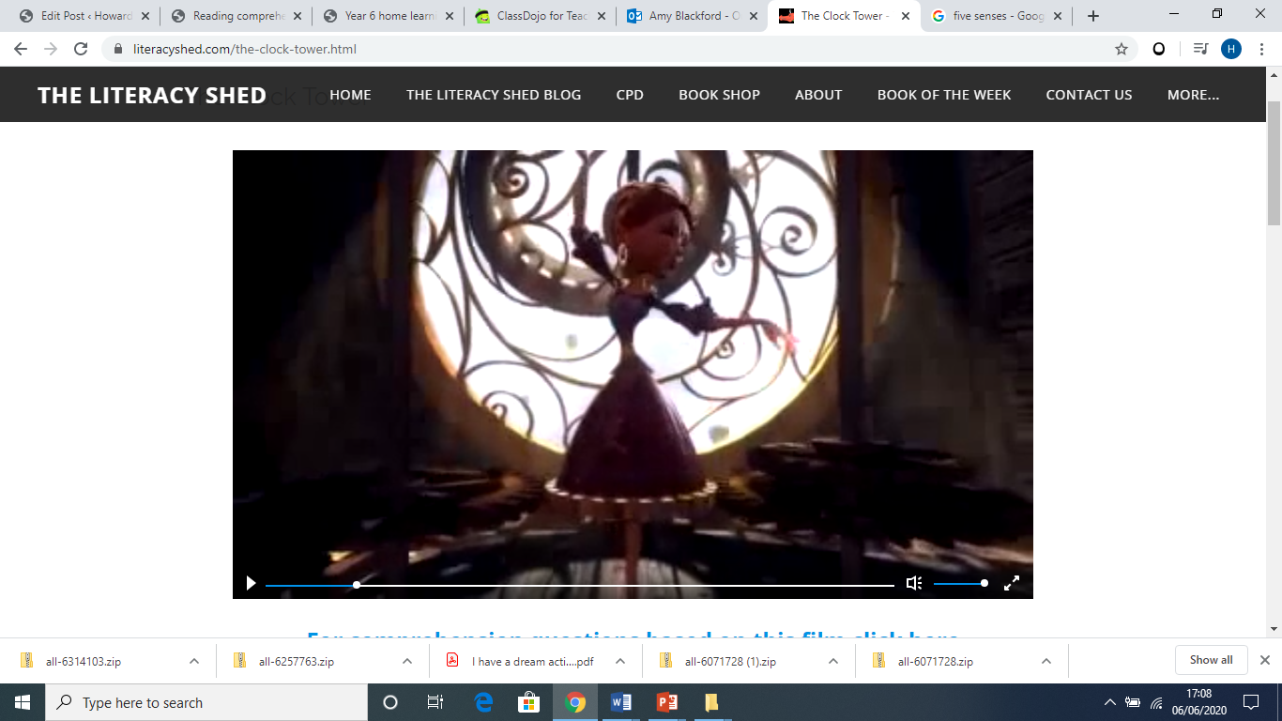

What can you feel?

What can you taste?

What can you smell?