LO: To understand the importance of Hajj for Muslims
Items used during the Days of Hajj by Muslims on pilgrimage
Items | Why I think it is used or What is symbolises
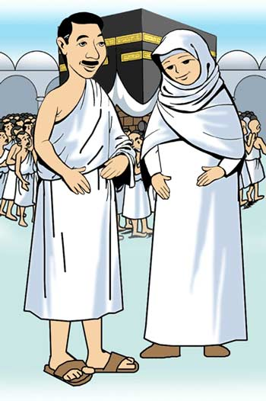 | Ihraam clothing for men and women:  _________________________________________________________________________________________________________________  _________________________________________________________________________________________________________________  _________________________________________________________________________________________________________________
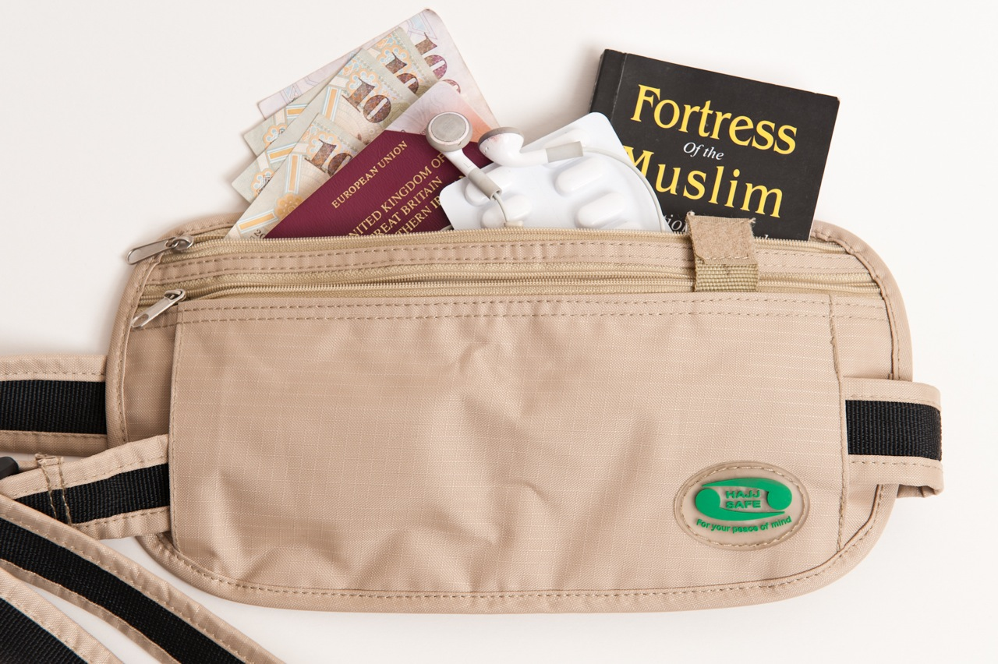 | Ihraam bag with medicine, money, passport and prayer books:  _________________________________________________________________________________________________________________  _________________________________________________________________________________________________________________  _________________________________________________________________________________________________________________
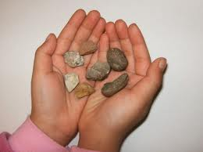 | 7 small stones:  _________________________________________________________________________________________________________________  _________________________________________________________________________________________________________________  _________________________________________________________________________________________________________________  _________________________________________________________________________________________________________________
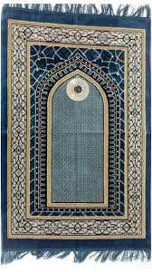 | Prayer mat:  _____________________________________________________________________________________________________________  _________________________________________________________________________________________________________________  _________________________________________________________________________________________________________________
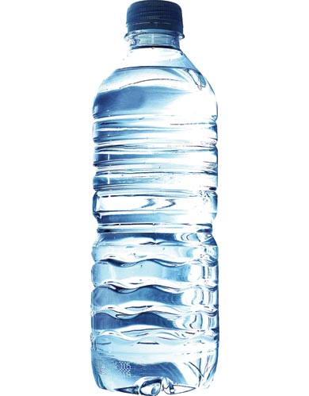 | Water:  _________________________________________________________________________________________________________________  _________________________________________________________________________________________________________________  _________________________________________________________________________________________________________________
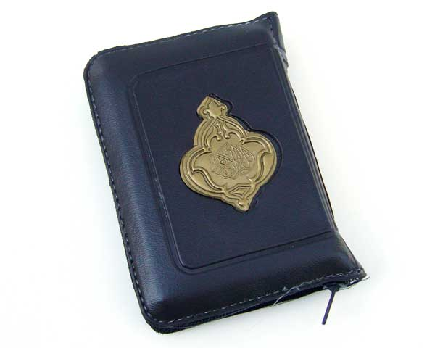 | Quraan:  _________________________________________________________________________________________________________________  _________________________________________________________________________________________________________________  _________________________________________________________________________________________________________________

