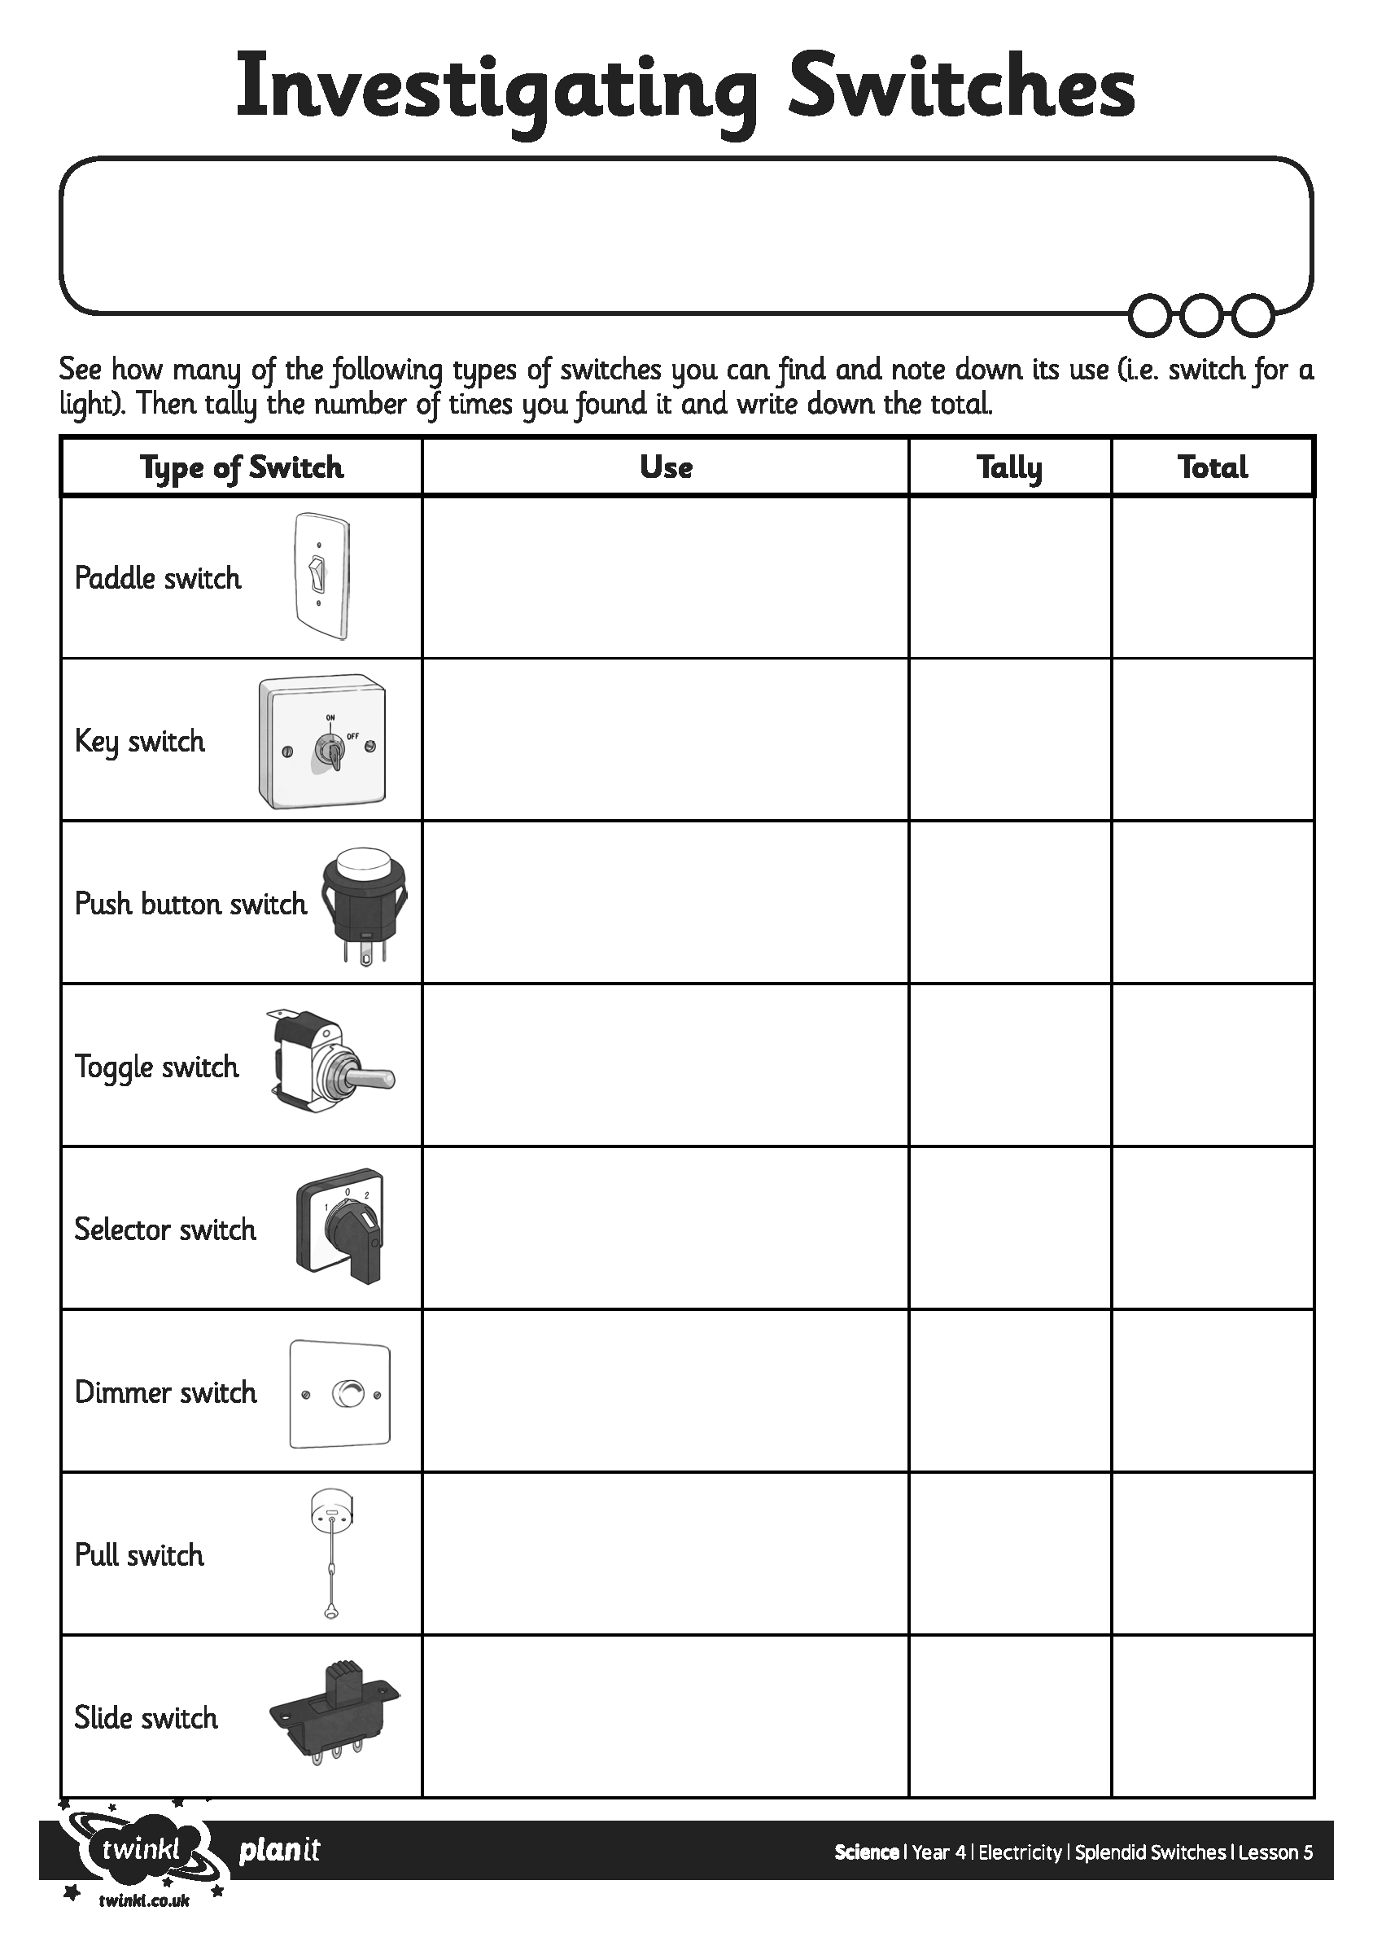
I can explain how a switch works and why they are needed.

