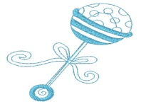
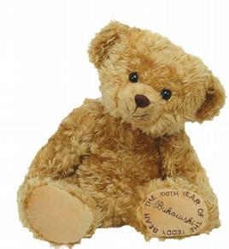
My life journey
(So far!)

My full name is _________________________________________
I like to be known as _____________________________________
I was born on ___________________________________________
I was born in (hospital/town name__________________________
I went to _______________________ nursery.
I went to _______________________ Primary School.
I am now in year ______________ and class _________________.

This is me as a baby: This is me today:

