Multiplication 2
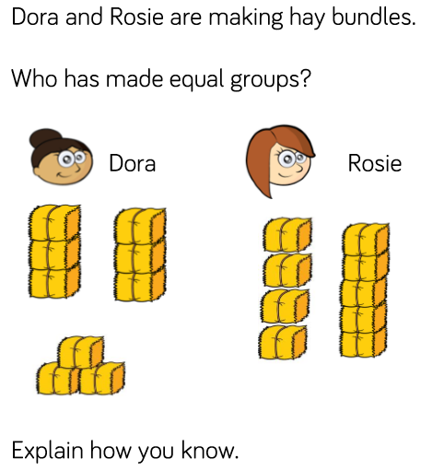

Complete the table
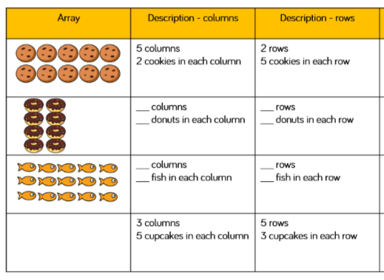

2 x 5 = 10
5 x 2 = 10
2 x 4 =
4 x __ = ___
3 x 5 = ____
5 x ____ = _____

3 x___ = ____
____x _____ -=_____

