Multiplication
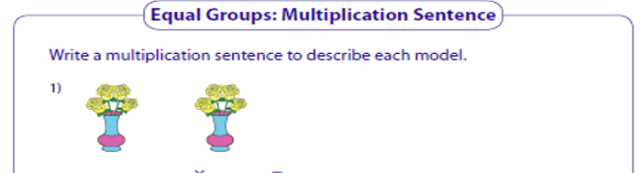
We are making equal groups
Example
2 groups of 4 = 8
2 x 4 = 8

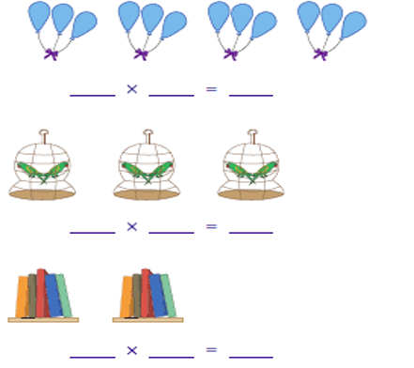
______ groups of ______ =

______ groups of ______ =

______ groups of ______ =
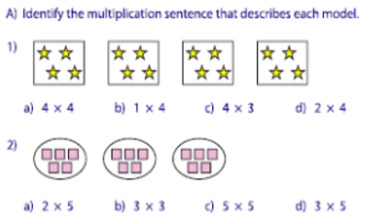
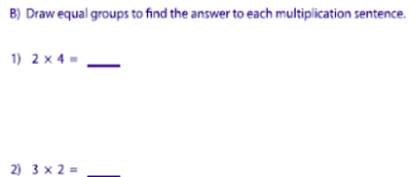
Circle the correct answer.

