Multiplication – Arrays 2

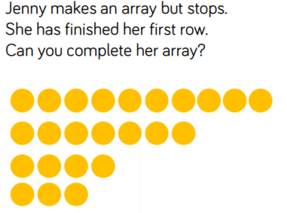

**Is this true ? Why ? Why not?**

