Money 1
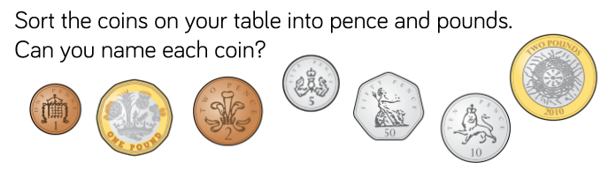
Pence | Pounds

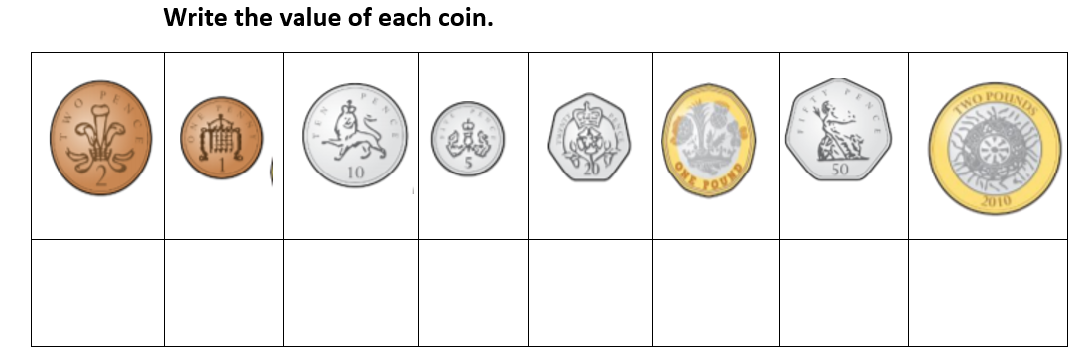

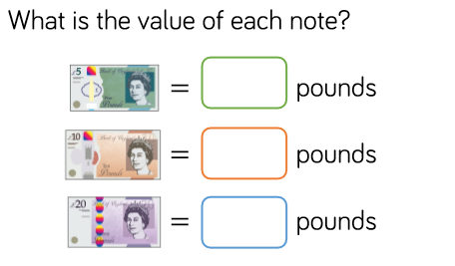

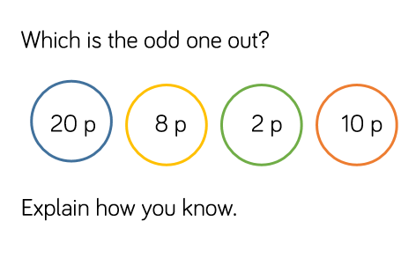
How many different ways can you make…
5 p 7p
10p 12p
15p 20p

