Name: 2nd June 2020

Science: I can identify reversible and irreversible changes and describe as well as explain (chemical) changes.

- Video: I identified these changes …
reversible | irreversible

- Reversible or irreversible?
    - Mixing water and plaster (Plaster of Paris ideally): ………………………...
    - Heating an egg: …………………….
    - Mixing bicarbonate of soda and vinegar: ……………………..

- Where does the water come from when I burn a candle?
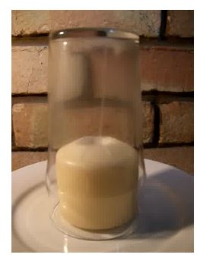
I think, the water comes from ...

- Mixing milk and vinegar:
  - Prediction: I predict that …
  - Describe what you observed.
In Science today, I have mixed boiling water with vinegar and ...

