Name: _______________ 5th June 2020

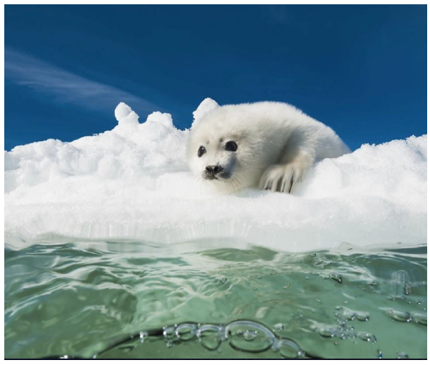
This is how it begins:

The young pup peered down into the icy water below with a growing feeling of trepidation. Only a few days old, she had learnt so much already from watching her mother, but this challenge was her greatest so far.
How would if feel to be submerged? What would she find lurking underneath the surface? How would she ever get back onto dry land?
Questions flooded her mind like a torrent of icy water, but bravely she inched closer to the edge. …

Questions – Please answer them:
- Where is the pup‘s mother?

- What animal is she?

- What might she have learnt already from her mother?

- How old is the pup?

- Do you remember learning to swim? What were the biggest challenges you had to overcome?

- Will the pup be brave enough to enter the water?

- How is it that some animals are better swimmers than others?

- How do you think it would feel to swim in that water?

- Would you be able to do it?

Sentence challenge – extend these sentences using relative clauses (who, which, where, when, whose, that).

e.g. The sky, which was the deepest blue you could ever imagine, offered the perfect background for this idyllic scene.

- The pup, who ………………………………….., prepared for the icy plunge.
- Her fur, …………………………………………….., camouflaged her almost perfectly.
- The water, …………………………………………………., was turquoise.

Sick sentences – Uplevel these sentences using relative clauses, expanded noun phrases, adverbial starters etc.:
- The pup lay on the snow.

- She looked at the water.

- It was a sunny day.

- It was cold.

Imagine, you had dived down into the water. What would you see.
First, draw what you would see.
Then, retell your adventure diving from the ice into the ocean and exploring the world below the surface.

