L.O. : I can use Line-Graphs to solve problems. 4/6/2020
Fluency:
1. Use the line-graph to answer these questions.
- What was the highest temperature?
- What was the lowest temperature?
- What time did they occur?
- What is the difference between the highest and lowest temperature?
- How long did the temperature stay at freezing point?

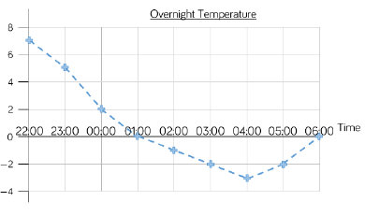

2) Use the line-graph to answer these questions.
- How long did it take for the pulse rate to reach the highest level? Explain using the graph.
- What could have happened at 5 minutes?
- What could have happened at 7 minutes?
- Estimate what the pulse rate was after 2 and a half minutes. How did you get an accurate estimate?

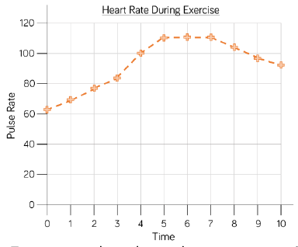

Reasoning

3) Some might have done that yesterday as an extension already, but if not, then please complete this: With a partner, carry out your own exercise experiment. First, record your heart rate in a table and then present your results on a line-graph. Finally, create 3-5 questions about your line-graph and answer them.

Diving Deeper:
4) The line-graphs shows the changing water-level at bath-time. Write a story to explain what is happening in the graph.
e.g.
- How long did it take to fill the bath?
- How long did it take to empty it?
- Why is there a difference?
- What happened when the height of water reached about 16 cm?

