L.O. : I can draw Line-Graphs. Date:
Fluency:
1) The table shows the average rainfall in Croydon over a year. Complete the graph.
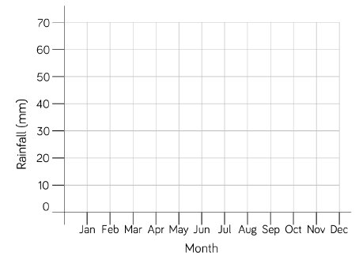
Month | Rainfall (mm)
January | 60
February | 42
March | 46
April | 48
May | 50
June | 50
July | 48
August | 54
September | 58
October | 64
November | 64
December | 64
Source: https://en.climate-data.org/europe/united-kingdom/england/croydon-6703/

2) Plot the conversion between pounds and rupees in a line-graph.

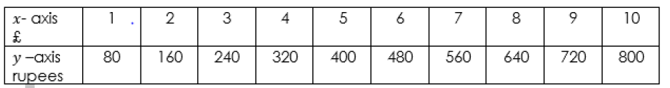

Reasoning & Diving Deeper:
3) Measure the temperature over a day starting at 9am all the way to 7pm. Measure every hour once (ideally at the full hour) and record the temperature. Then put the data into a line-graph.
Time | 9am | 10am | 11am | 12am | 1pm | 2pm | 3pm | 4pm | 5pm | 6pm | 7pm
Temperature in °C

4. Rosie has used the data in the table to plot the line graph. What mistakes has she made?
Draw the line-graph correctly.

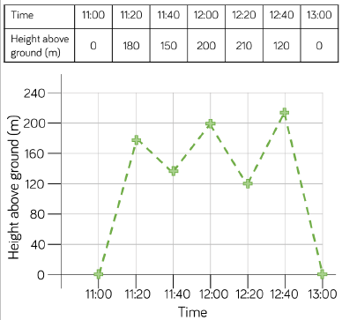

Challenge: Find/Decide on a variable that’s change you can measure over time.
- Measure and draw a line-graph. e.g. your pulse while exercising (after 1min, 2min ...)

