Creative Writing – Friday, 22nd May 2020
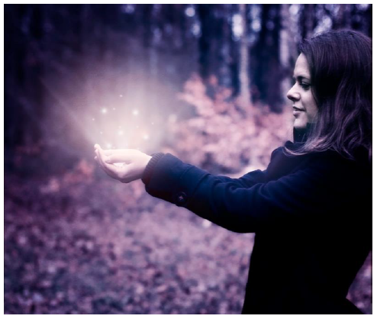
Astrid held out her hands. She was alone in the forest and an eerie silence surrounded her. All she could hear was the faint buzz, like a bee settling down on a flower, coming from the thing she held so protectively in front of her.

Her hands were suddenly filled with a comforting warmth, as a silvery light pulsed from the object. A tingle ran down Astrid’s spine.

“It must be magic …” She muttered excitedly under her breath … “It must be!”

Before you start using this as your story beginning, please complete the following tasks:

- Guess:
  - What could Astrid be holding in her hands? Explain how you know.

  - Is magic real?

  - Where did she find the item?

  - Why is she all alone in the forest?

  - What could happen next?

- Use a simile to complete the description in the following sentences.
  - The light glowed in her hands like …

  - The noise was rising from the thing in her hands like …

  - Suddenly, the orb (orbit) exploded like …

- Improve these sentences (metaphors, similes, alliteration, personification, expanded noun phrases etc.):
  - Astrid stood in the forest.

  - Astrid held out the stone in her hands.

  - It started to glow.

- Now, please continue the story (50-100 words) …
Use figurative language, ambitious language for effect, 3rd person, persistent tenses, fronted adverbials, complex sentences, (e.g. subordination and co-ordination), a range of accurate punctuation …

