Creative Writing – “Catch it”

Watch: https://www.youtube.com/watch?v=c88QE6yGhfM

Answer the questions (Question-Time):
  - Describe the landscape the meerkats are living in.

  - What could the vulture say to itself as it lands on the tree and sees the fruits?

  - Why do the meerkats all want to catch the fruit?

  - What sports is represented in the clip?

  - What could be the moral of the story?

  - A group of meerkats is called a “mob”. What collective noun do we use for these animals?

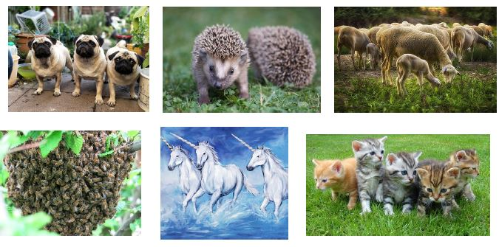
Now, please think what the vulture and meerkats could say to each-other.
→ Write possible speech/dialogue into the speech-bubbles.

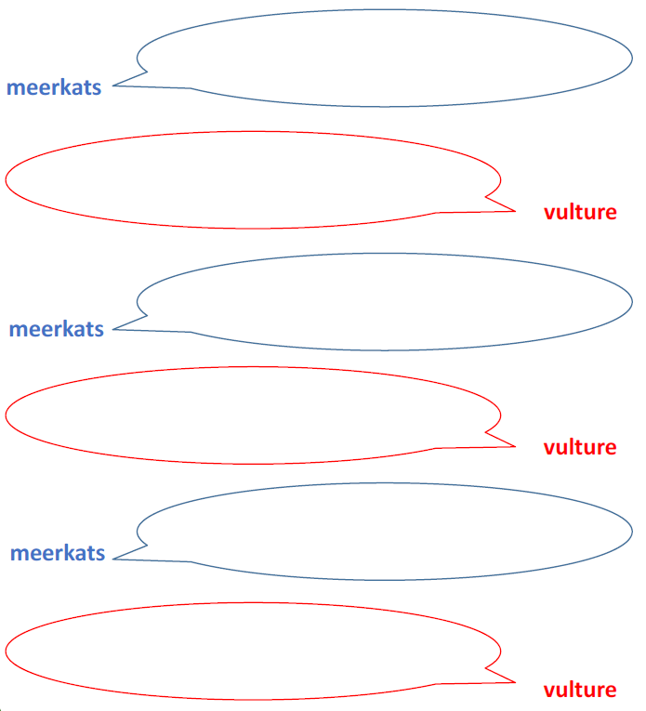

Now, imagine to be one of the meerkats and it is retelling the events from its own perspective. This could be to other meerkats, its pups, a Scientist (if they speak Meerkat-language – What name could this language have?) or its diary (Did you know that meerkats can write?).

Here are some ideas/prompts of what I expect to see in your writing.
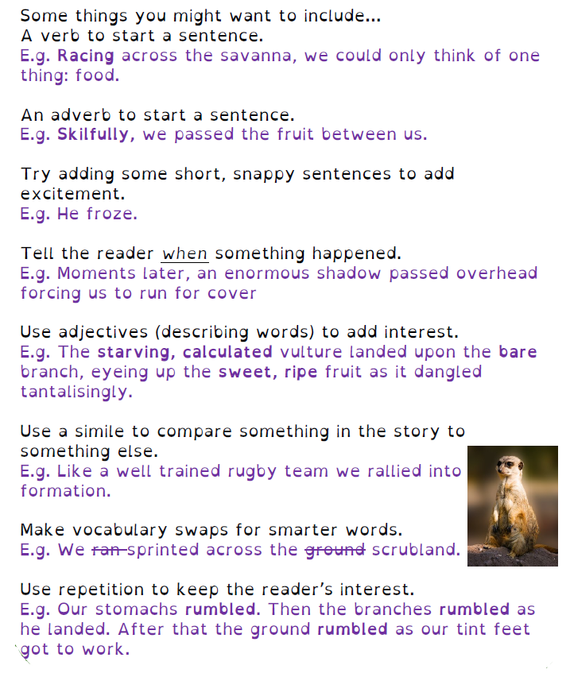

____________________________ (title)

...

