Name:
Date:

LO: I can identify and find equivalent fractions – Extension (Diving Deeper)

- Do you agree or disagree? Explain your answer.
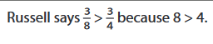

- Which one is closer to 1? Explain how you know.
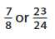

- Chiz and Caroline both had two sandwiches of identical size.
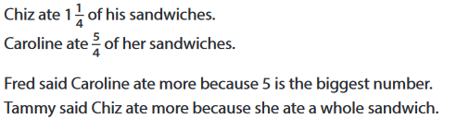
Explain how you know that Fred as well as Tammy are wrong.

