L.O.: I can use prompts to develop my own diary writing.

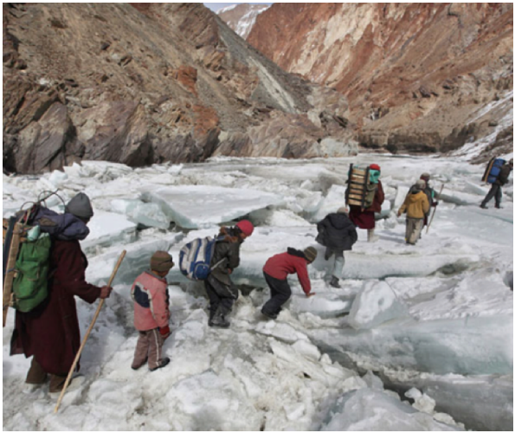

Tasks:
- Describe what you think happens in the picture. Include who these people are, where they are going, why, etc.
    - …

- Explain in your own words what an article (Think of Grammar).
    - An article in grammar/SpaG is …

- Underline the articles in the following two sentences.
    - The children walked across the ice.
    - They heard an almighty crunch beneath their feet.
    - A tall mountain stood right in front of them.

- Improve these three sentences.
    - It was very early.
      - ...
    - We walked across the ice.
      - ...
    - It was cold.
      - ...
- Think:
    - These children are on their way to school Describe their journey in 2-3 sentences.
      - ...
    - How does their journey to school compare to yours (similarities and differences)?
      - ...
    - Where in the world are they?
      - ...
    - Who are the adults?
      - ...
    - How would these kids react if they could spend one day in your school.
      - ...

- Continue the diary entry.

...
6AM: I left the house on my own, wrapped up in my warmest coat (which I wear
every day) to make the 3km trip. I met up with other children from my village, and we huddled together beneath the mountain to keep warm, waiting for the last couple of stragglers to arrive. As soon as we were all together, two of the dads put their sledges and emergency packs on their backs, and we set off for
school…

Extension: Draw a picture of their school.

