Monday, 11th May 2020

Starter:

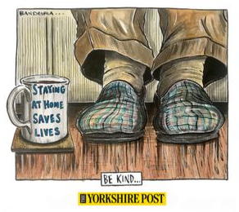
        - What is the picture telling us (message)?
        - How have you found being at home?
        - How are people helping each other during this difficult situation?
        - What top 3 pieces of advice would you give to people who might be getting bored of being stuck at home?

I can use the 5 senses to describe a setting (and develop this into a story).

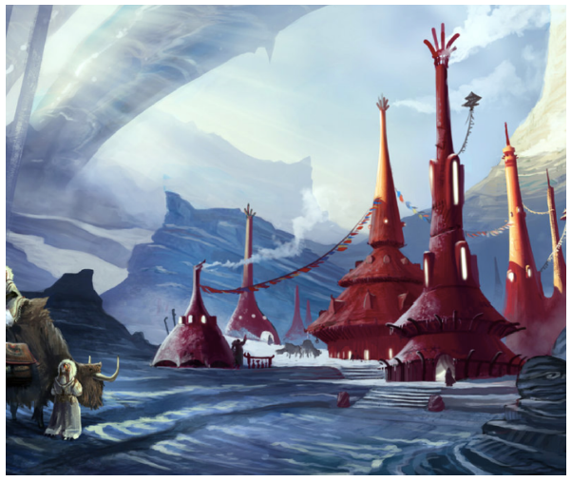
Warm-up: Write into the table words and phrases to describe using the 5 senses.
See | Hear | Feel | Taste | Smell
... | ... | ... | ... | ...

Main Tasks:
- Extending descriptions:
    - Make a list of nouns you can see in the picture.
      - ...
    - Make a list of adjectives to describe those nouns.
      - ...
    - Make a list of verbs to describe what the nouns in the picture are doing.
      - ...
    - Can you make a sentence using at least 1 verb, noun and adjective from your lists?
      - ...
    - Can you add an adverb to your sentence?
      - ...

- Question Time:
    - Who are the travellers?
      - ...
    - Where have they come from?
      - ...
    - How have they made the journey?
      - ...
    - What is the place they have come to?
      - ...
    - Have the travellers been here before?
      - ...
    - What will happen now that they have arrived?
      - ...
    - Why are the building designed like that? Explain.
      - ...

- Improve the sentences using as many of the 5 senses as possible.
    - The houses were big and red.

    - They were really big and had smoke coming from them.

    - The girl stood in the snow.

    - She was happy.

    - She was tired.

EXTENSION:

They had travelled so far to see this place. Their journey had not been easy; she hoped it had been worth it.

→ Can you continue the story? Try to describe the setting in great detail.

