Monday | - TL – How did families survive during the war on rationed food?  Imagine you are part of a family during World War Two.  - There are 4 members of your family. Mum, dad, brother/sister.  - Each of you are given a ration book, containing the following items. You are only allowed to use these items.  - Create a menu for 4 evening meals over 4 days. You are not allowed to have any extra amounts  - Please check if you can have other things.  - Ration Book Items  Butter: 55g (2oz) Bacon and ham: 110g (4oz) Margarine: 110g (4oz)  Sugar: 220g (8oz). Meat: To the value of 1s.2d (one shilling and sixpence per week. That is about 6p today) Milk: 3 pints(1800ml) occasionally dropping to 2 pints (1200ml).  Cheese: 55g (2oz) Eggs: 1 fresh egg a week. Tea: 55g (2oz).  Jam: 220g (8oz) Dried eggs 1 packet every four weeks. Sweets: 330g (12oz) every four weeks  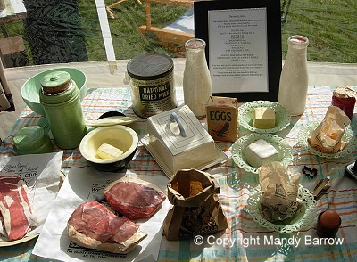  Grown in your garden  Carrots, potatoes, cabbage, raspberries, apples, cauliflower,  Cows – extra milk  Chickens – extra eggs  Some foods such as potatoes, fruit and fish were not rationed.
Monday- Create 4 separate evening meals for your family of 4. You can record the meals however you want. You may choose to research WW2 meals that would have been available or you can choose to make up your own meals based on your preferences now.
Make sure you know how much of each ingredient you would need.
Tuesday-Use the prices on the powerpoint to work out the cost of the shopping you would need to buy for these 4 meals.

