**2020 National curriculum tests**

**Maths Paper 5**

**Key Stage 2**

|  |  |
| --- | --- |
| First name |  |
| Middle name(s) |  |
| Last name |  |
| Date of birth |  |
| School name |  |

**Instructions**

You should work through the booklet until you are asked to stop.

Work as quickly and as carefully as you can. If you get stuck, move onto another question.

You can revisit difficult questions later. If you finish before the end, go back and check your work.

**Marks**

There are 5 questions and each question is worth 1 mark.

A square number and a prime number have a total of 22. What are the 2 numbers?

**1**

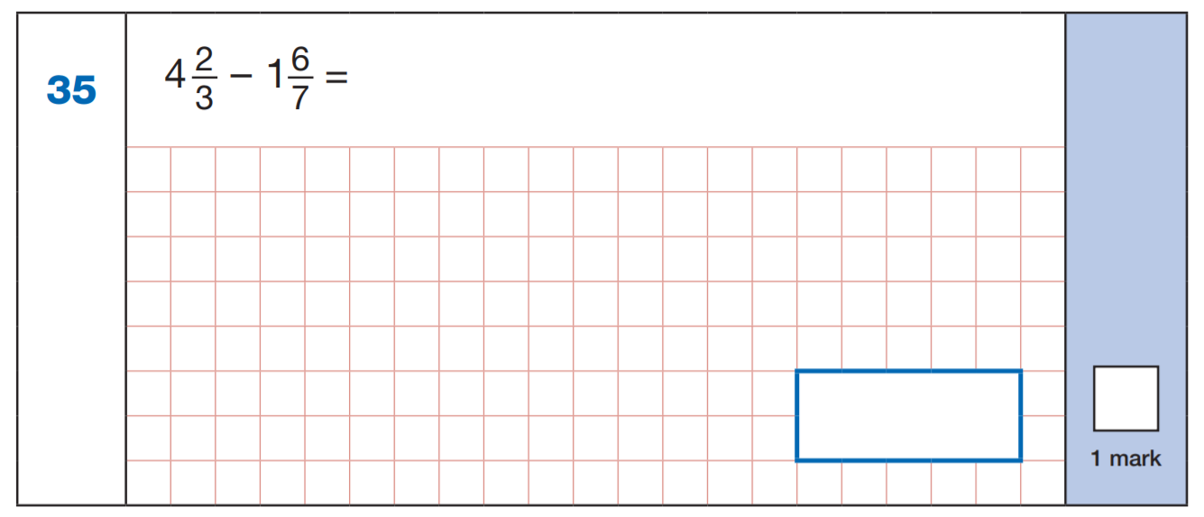

**2**

56.38 + 24.7 =



A group of friends at Howard earn £80 by washing cars. They share the money equally. They get £16 each. How many friends are in the group?

**3**



**4**

Last year Miss Handley and Miss Blackford went to 5 concerts. Each ticket costs £7 for Miss Handley and £5 for Miss Blackford.

How much was paid in total?



3 bags of pasta cost the same as 2 bags of flour. Each bag of flour of flour costs £1.35. How much does a bag of pasta cost?

**5**

