2020 National curriculum tests
Maths Paper 4

Key Stage 2

First name
Middle name(s)
Last name
Date of birth
School name

Instructions

You should work through the booklet until you are asked to stop.

Work as quickly and as carefully as you can. If you get stuck, move onto another question.

You can revisit difficult questions later. If you finish before the end, go back and check your work.

Marks

There are 5 questions and each question is worth 1 mark.

If n= 12, complete the following n-4 = ?
1

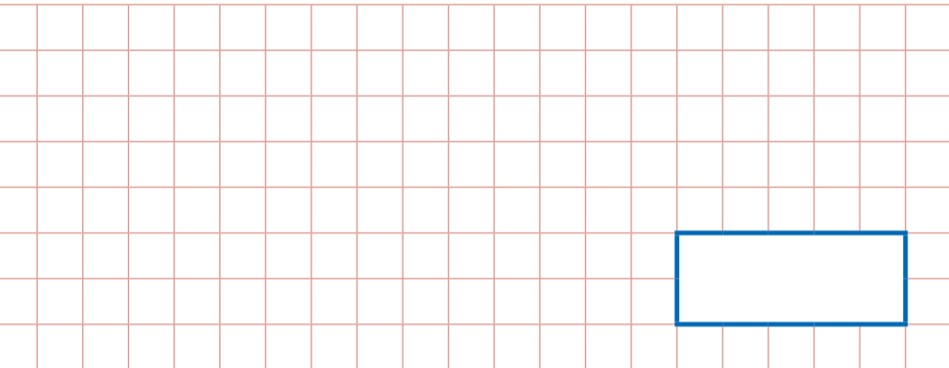

2
Mr Govinden recorded a programme on the television. It started at 1.35pm and finished at 2.17pm. How long was the programme?

6 squared + 10 =
3

4
If the temperature at Howard Primary School in the day was 12 C and at night was -2 C.
What is the difference in the 2 temperatures?

Continue the sequence:
5

245, 679; 245, 689; 245, 699; ________, _________

