2020 National curriculum tests
Maths Paper 3

Key Stage 2

First name
Middle name(s)
Last name
Date of birth
School name

Instructions

You should work through the booklet until you are asked to stop.

Work as quickly and as carefully as you can. If you get stuck, move onto another question.

You can revisit difficult questions later. If you finish before the end, go back and check your work.

Marks

There are 5 questions and each question is worth 1 mark.

The children at Howard Primary School were collecting money for charity. Their target is to raise £360. They have raised £57.73. How much more money do they need to raise?
1

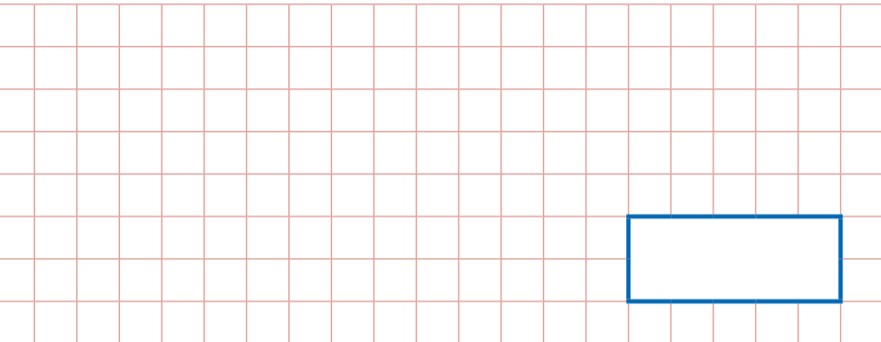

2
Miss Blackford thinks of a whole number. She multiples it by 4 and rounds the answer to the nearest 10. The result is 50. What could the numbers be?

? – 10 = 208
3

4
Miss De Saulles uses the cards 5, 6, 9
She makes a 2 digit number and a 1 digit number. She multiples them together. Her answer is a multiple of 10. What could her multiplication be?

Miss Brown completes the following calculation: 95-67=28. Write an addition calculation she could use to check.
5

