2020 National curriculum tests
Maths Paper 1

Key Stage 2

First name
Middle name(s)
Last name
Date of birth
School name

Instructions

You should work through the booklet until you are asked to stop.

Work as quickly and as carefully as you can. If you get stuck, move onto another question.

You can revisit difficult questions later. If you finish before the end, go back and check your work.

Marks

There are 5 questions and each question is worth 1 mark.

If there were 56 pupils in Year 6 and they each had 4 pencils, how many pencils would there be in total?
1

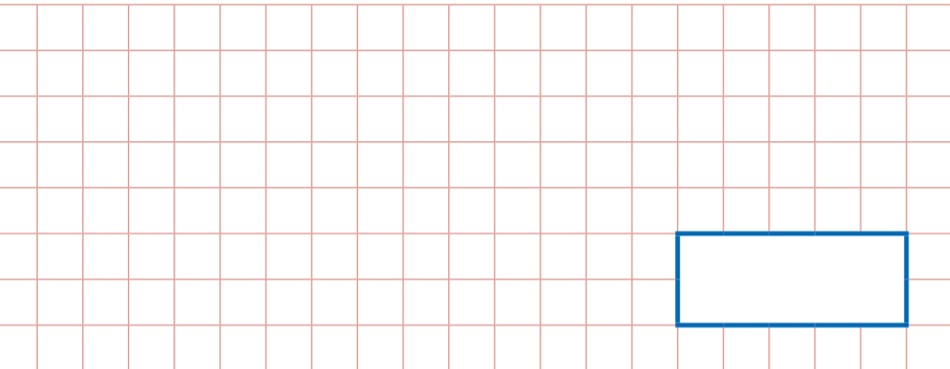

2
There are 420 pupils at Howard Primary School. If 2/5 of them were boys, how many girls would there be?

Miss Blackford buys 3 large boxes of chocolate and 2 small boxes of chocolates. Each large box holds 48 chocolates and each small box holds 24 chocolates. How many did Miss Blackford buy altogether?
3

4
Match the numbers that are equivalent to ¼:

25/100, 1.4, 0.5, 2/5, 0.25

Write 3 factors of 30 which are NOT factors of 15
5

…………………………………………………………………………………..

