2020 National curriculum tests
Maths Paper 2 - LA

Key Stage 2

First name
Middle name(s)
Last name
Date of birth
School name

Instructions

You should work through the booklet until you are asked to stop.

Work as quickly and as carefully as you can. If you get stuck, move onto another question.

You can revisit difficult questions later. If you finish before the end, go back and check your work.

Marks

There are 5 questions and each question is worth 1 mark.

Miss Handley has a bottle of milk that holds 568ml. If she pours out 500ml, how much is left?
1

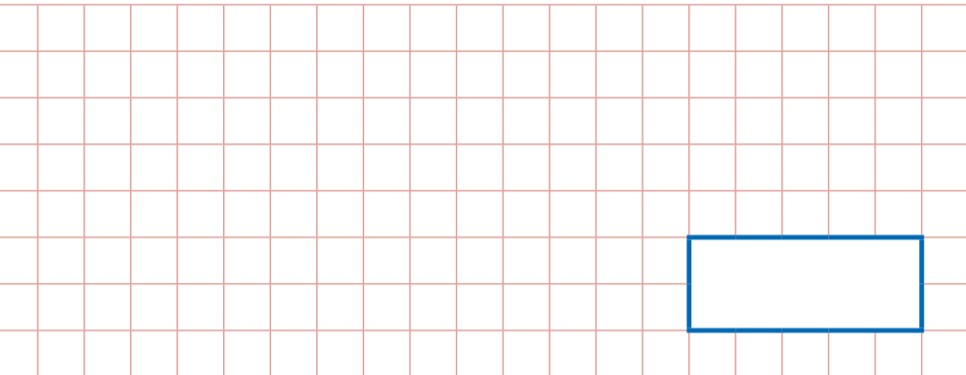

2
A bicycle travels for 3m. What is that in cm?

706 – 52 =

3

4
Look at the following letters. Circle the letter that has not straight sides

A C E L Z

A packed lunch shelf holds 7 packed lunches. There are 3 shelves. How many packed lunches are there altogether?
5

