Name: … 13th May 2020
LO: I can explain how erosion and deposition form and threaten the coast.

After watching the videos, please label the pictures with the correct vocabulary.
If needed, use googe-search for help.

Words: lagoon, stump, stack, cliff, sand dunes, beach, cave, bay, headland, arch, spit

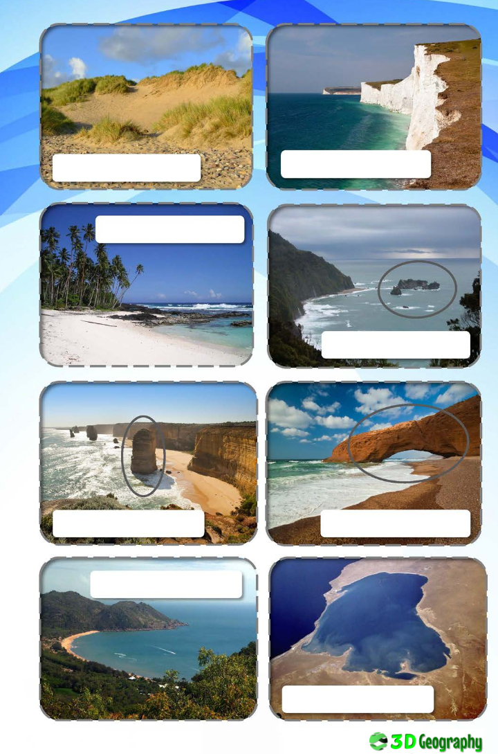

If you haven‘t done so yet, please create a glossary for your Geography book. (Explain these words/processes)
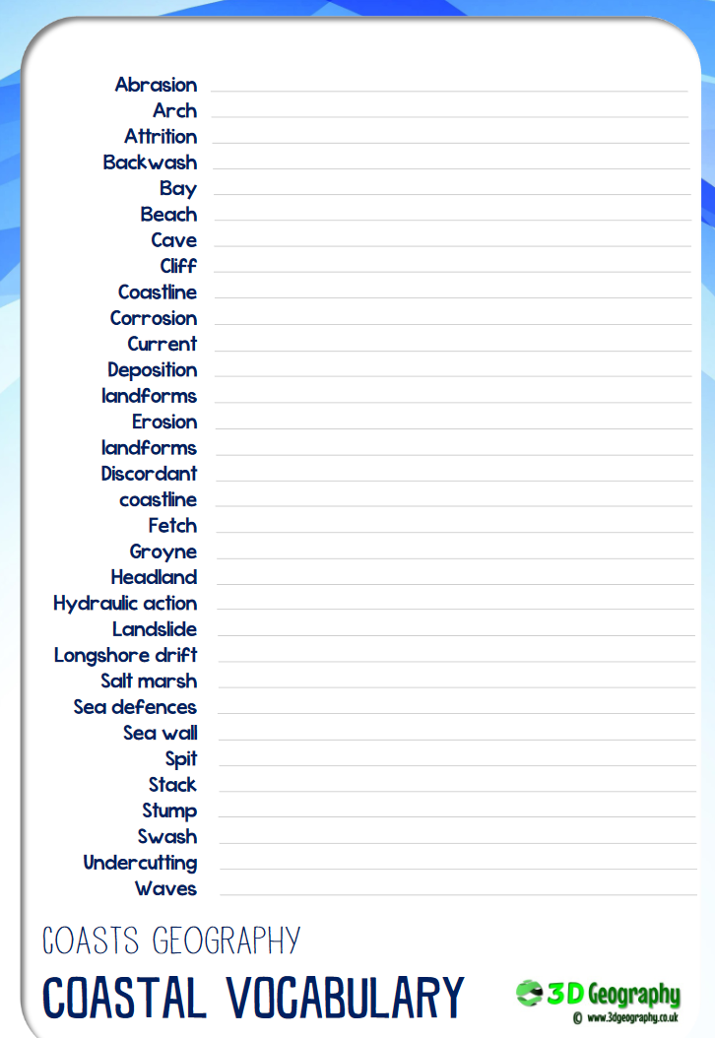

To secure your knowledge, have a go at solving this.
