Name: … 6th May 2020
LO: I can explain how coasts are formed.

Read the text and then draw a sketch/picture.

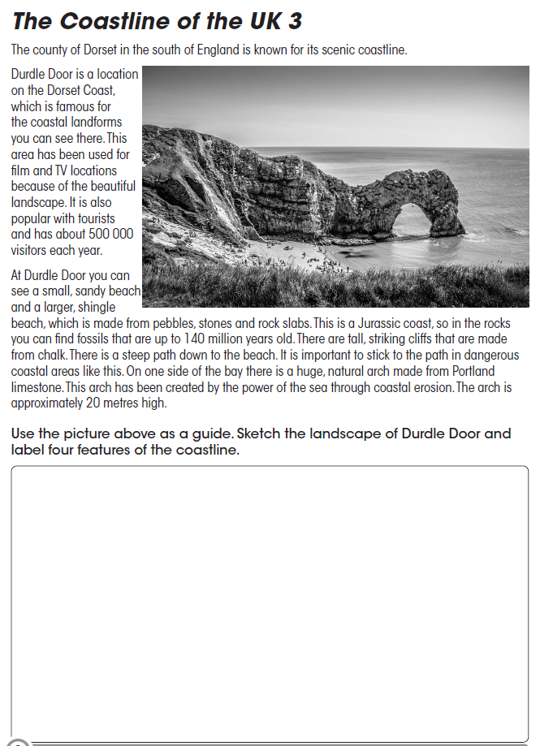

What do you think “Durdle Door“ will look like in 100 years time?
…

Glossary (Explain these words/processes on a small piece of paper and attach it to your presentation.
  - erosion, deposition, tide, wave, current, longshore drift, hydraulic action, corrosion, attrition, abrasion, arch, stack, stump, spit, lagoon, cove, fjord, salt-marsh

