Name of god:

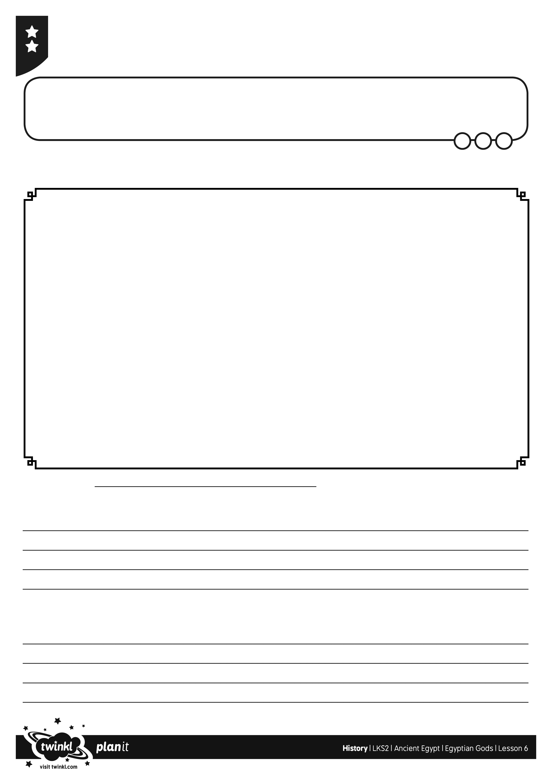
I can compare and contrast the powers of different Egyptian gods.

Ancient Egypt’s Got Talent

Fill in this sheet to help you prove to the judges that your group’s god is the most talented.

Why are gods important to ordinary Egyptian people?

Name of god:

Describe the god’s appearance (how it looks):

What is special about your gods?

