Tuesday, 21st April 2020

I can use language for effect in story starters (figurative language etc).

Warm-Up I: Write down 5-10 different words and phrases to describe the picture.
- Challenge: Use ambitious vocabulary and figurative language.

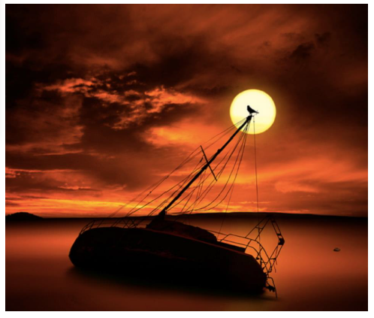

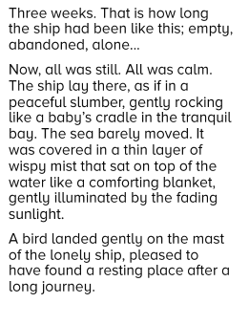
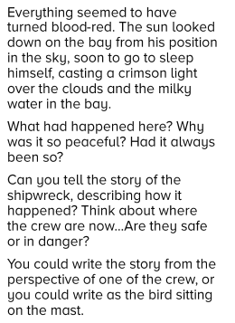
Reading:

Questions:
- What colour is the sea?

- Why is the sea not blue?

- Where have the crew gone?

- How long has the ship been like this?

- What is the difference between a sea and an ocean? (Is there a difference?)

- What is the difference between a lake and an ocean?

- If a millionaire is shipwrecked on an island, are they still a millionaire?

Figurative Language
Personification is when you give human qualities to an object or animal. It adds interest or understanding to a poem or story.
e.g. lightning danced across the sky; the wind howled in the night; …

Task: Create 3-5 examples of personification for the picture on the first page.
- …
- …
- …

Sentence up-levelling:
Improve the following sentences. Can you add an adverb and other narrative devices?

- The sun was in the sky.

- It was a warm evening and the sun shone on the water.

Thinking deeper – drawing and describing.
Speculate/Guess how the ship could have become shipwrecked.
- …
- …
- …

Choose your favourite guess/speculation and draw a picture to it. Then describe what happened. This can happen in the form of (choose one form) …
- a diary entry from a crew-member,
- an eye-witness report,
- a narration by a narrator who is not in the story. This can be an objective, a limited or an omniscient narrator.

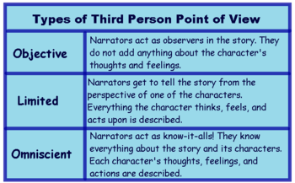

Have fun. We are looking forward to your responses.

