Name: _________________________ Date: 28th April 2020

LO: I can explore what I already know about different materials.

My Materials-Hunt

Item (where the material is used) | Name of the main material used | Picture or sketch | Properties of the material (describe the item and material) | Benefits of the material (e.g. Why is it used for this item?) | Weaknesses of the material (if known)
Office Chair | Plastic (cover) | 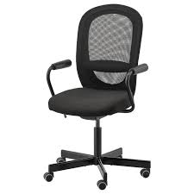 | Solid,  easy to shape (when plastic is liquid),  hard,  opaque,  artificial/man-made,  durable,  ... | Easy to shape in production (+ relatively cheap to make)  solid to keep its shape  durable to last long and be easily cleaned  ... | Tires (as the plastic gets older it gets weaker)  Not recyclable (currently)  irreparable when is breaks / snaps  ...

What is positive, negative and fascinating about a chocolate door handle.
Positive | Negative | Fascinating

