Please solve the following problems. Question 3 can only be done if you have a printer.

Have fun.

- Keep on halving (you can solve it in your brain without a calculator)

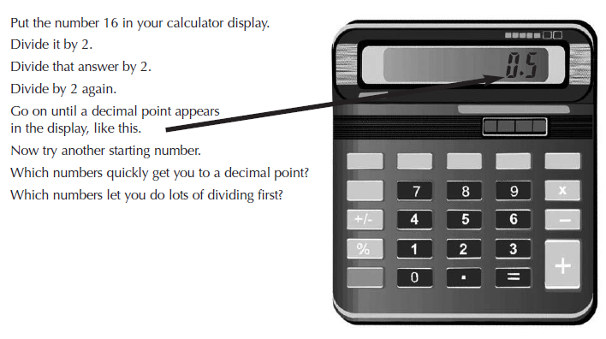

- Fraction patterns
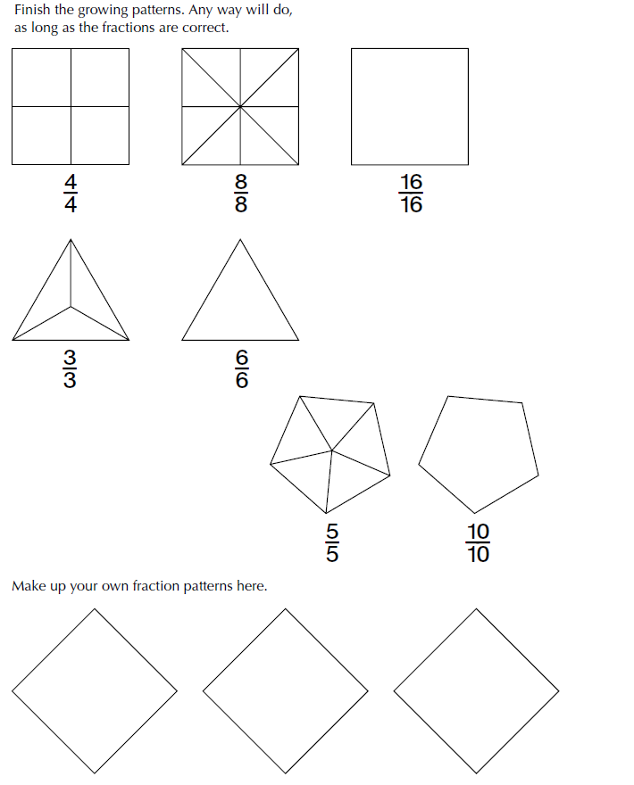

- Decimal Jigsaw
