Tuesday, 28th April 2020

I can use suspense in story starters.

Warm-Up: Write down 5-10 things that the boy from the picture could see.

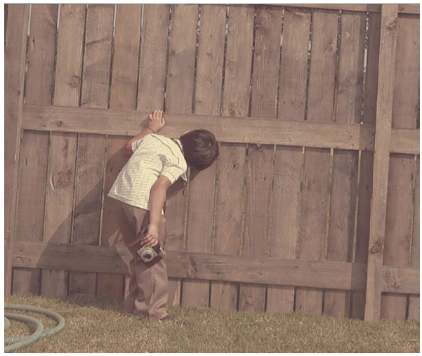

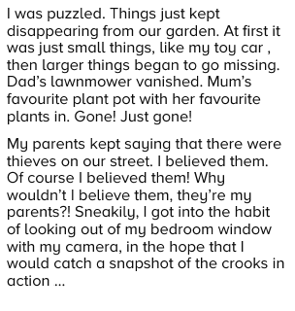
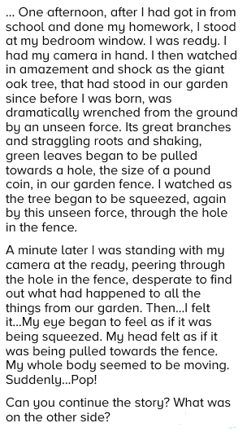
Reading:

Questions:
- If you could take photographs of the 5 happiest moments in your life, what would they show?

- What 5 events of the future (as far as you know), would you like to take a photograph of? Explain why.

Language
Write down 5-10 feelings the boy could have.
- …
- …
- …
- …
- ...

Now, take these feelings and use them at the beginning of sentences. e.g.
- curious → Curious, the boy peeked through the hole in the fence.

- …
- ...
- …
- …
- ...

Sentence up-levelling:
Improve the following sentences. Add adverbs and other narrative devices to build tension.

- The boy went towards the fence.

- He looked through the hole.

- He was excited.

Thinking deeper – drawing and describing.
Draw what you think the boy is seeing through the fence. (draw on class-dojo or paper → take a picture and send us)

Then describe what he sees using words, phrases, figurative language and also expanding into the 5 senses where possible.
- …
- …
- …

