Homework (due by Wednesday, 22nd April 2020)

Reading: Please keep up reading daily and record what you have read in your diary.

Spellings:
- Over the holidays, focus on a range of spelling “building sites” and present your work in the form of a poster or leaflet. Each word needs to be presented in beautiful (joined up) handwriting and within a sentence. In addition, choose one other means of practising (e.g. mnemonics, rainbow-words, pyramid-words, quick-write, trace, draw around the word, Look-Say-Cover-Write-Check, word-outline and sentence writing).
Use 5-10 words of your own choice that you have repeatedly spelt incorrectly in the past.
- Spot and explain the mistakes:
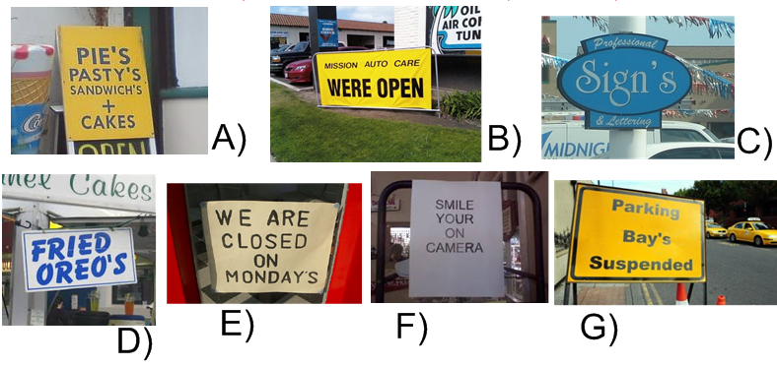
English/Reading/Writing & Science
- Research and create a factfile/poster about one of the following famous scientists:
    - Isaac Newton
Include:
- Keypoints in the person’s life (birth, education, career, family life)
- Main discoveries and inventions
- Legacy – How do we benefit from the scientist’s achievement today?
- Fun-/Keyfact (e.g. Did you know …?
    - Marie Curie
    - George Washington Carver
    - Charles Darwin
    - Ada Lovelace
    - Ibn al-Haytham
    - Jane Goodall
    - Louis Pasteur
    - Jagadish Chandra Bose
- Useful websites:
  - http://discovermagazine.com/2017/may-2017/heroes-of-science
  - https://www.ducksters.com/biography/scientists/scientists_and_inventors.php
  - https://www.famousscientists.org/
… any targeted “google” search will supply you with a wealth of information.

Maths:
Complete the revision tasks on White-Rose-Math (see link on the class-blog: https://whiterosemaths.com/homelearning/year-5/)
Further tasks will be set on Mathletics. Use the time to catch up with all the tasks you have not yet completed to a good degree.

Have a relaxing and sunny Easter holidays.
The Year 5 team

