Science-Lesson 1
Classification
LO-I can classify animals

What does classification mean?
-It is the arrangement of animals and plants in groups according to their similarities
Why do we classify animals and plants into particular groups?
-It is important to group animals and plants so that we can narrow them down into specific groups
-Scientists believe that there may be as many as 10miliion different species on Earth. When studying their lives and behaviours, it is important to have narrowed them down into different groups so that they can research the appropriate groups.
A simple way to group animals is through a key that asks questions to separate down to the animal/s. You can also classify animals through specific headings eg-4 legs, not 4 legs.

Recap-
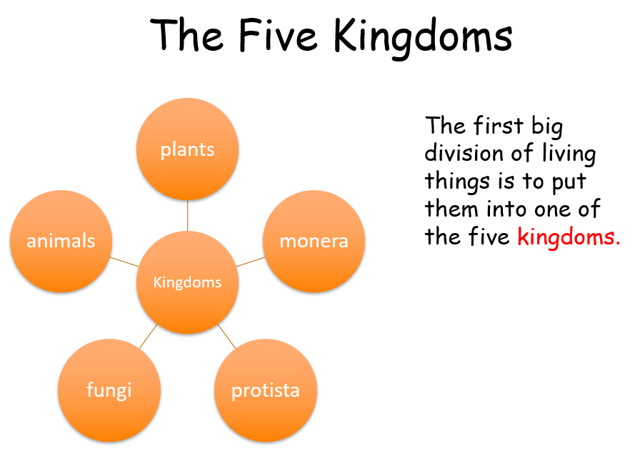
Carlus Linnaeus decided to group all things into 5 categories which he called 5 kingdoms. We are going to look at the animal kingdom today.
The animal kingdom can be split into 2 groups:
- Vertebrate
- Invertebrate
The vertebrate group can then be split into 5 groups- (Mr. Fab is a way to remember the groups).
M-Mammals
R-Reptiles
F-Fish
A-Amphibian
B-Bird

You could draw a diagram to show that, as follows-
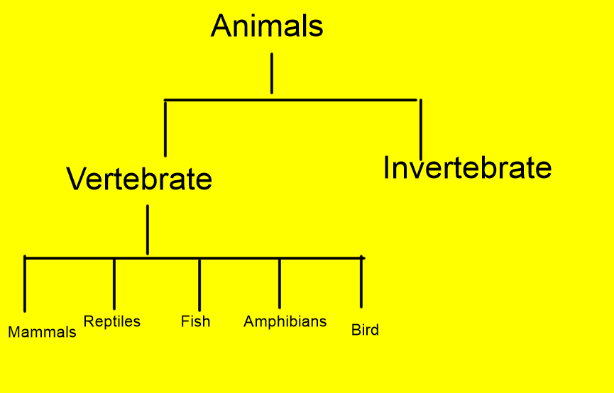

Your work this week is to find out what the features are of each group (Mr Fab).
What makes a mammal a mammal?
What makes a reptile a reptile?
…….and so on.
You can record the information you learn in a poster, bullet points or any other way you would like.
Dojos will be on offer!
Happy researching!

